CollegeNet-25Live Frequently Asked Questions - Requestors

25Live is the online scheduling component of CollegeNET. This document answers frequently asked questions about the 25Live scheduling system.

- Q. How do I access 25Live and who can use it?
- To gain access to 25Live you must have a Penn State WebAccess login account. You can log in at the following link: Penn State CollegeNET https://25live.collegenet.com/pro/psu. CollegeNet is available to Faculty, Staff and students. If there are locations in the system that you cannot request, or locations that you do not find in the system, please contact the controlling unit directly.

- Q. Is it required that I use 25Live to schedule events?
- 25Live is used for scheduling courses, meetings, events, and calendaring. The expectation is that all space scheduling will eventually occur through this unified platform. A phased roll-out began in August 2016. Please contact units directly for locations that are not found in or requestable through 25Live.

- Q. Why can’t I see any locations, resources, or organizations?
- If logging in for the first time you will not be able to view many areas of 25Live. Please allow two business days for your 25Live account to be verified and updated with your appropriate campus access. If you are still experiencing viewing issues after the 2 day wait period please contact events@psu.edu.

- Q. How do I sign out of 25Live?
- To sign out of 25Live please close your browser. Log out will occur at that time. A “sign-out” button is not provided due to WebAccess log in restrictions.

- Q. Can I customize my Dashboard?
- You can customize the view of your Dashboard by mouse clicking on the Customize Dashboard wheel in the lower righthand corner of the dashboard. You can click and drag elements withing the dashboard and or remove an element you wish not to be visible.
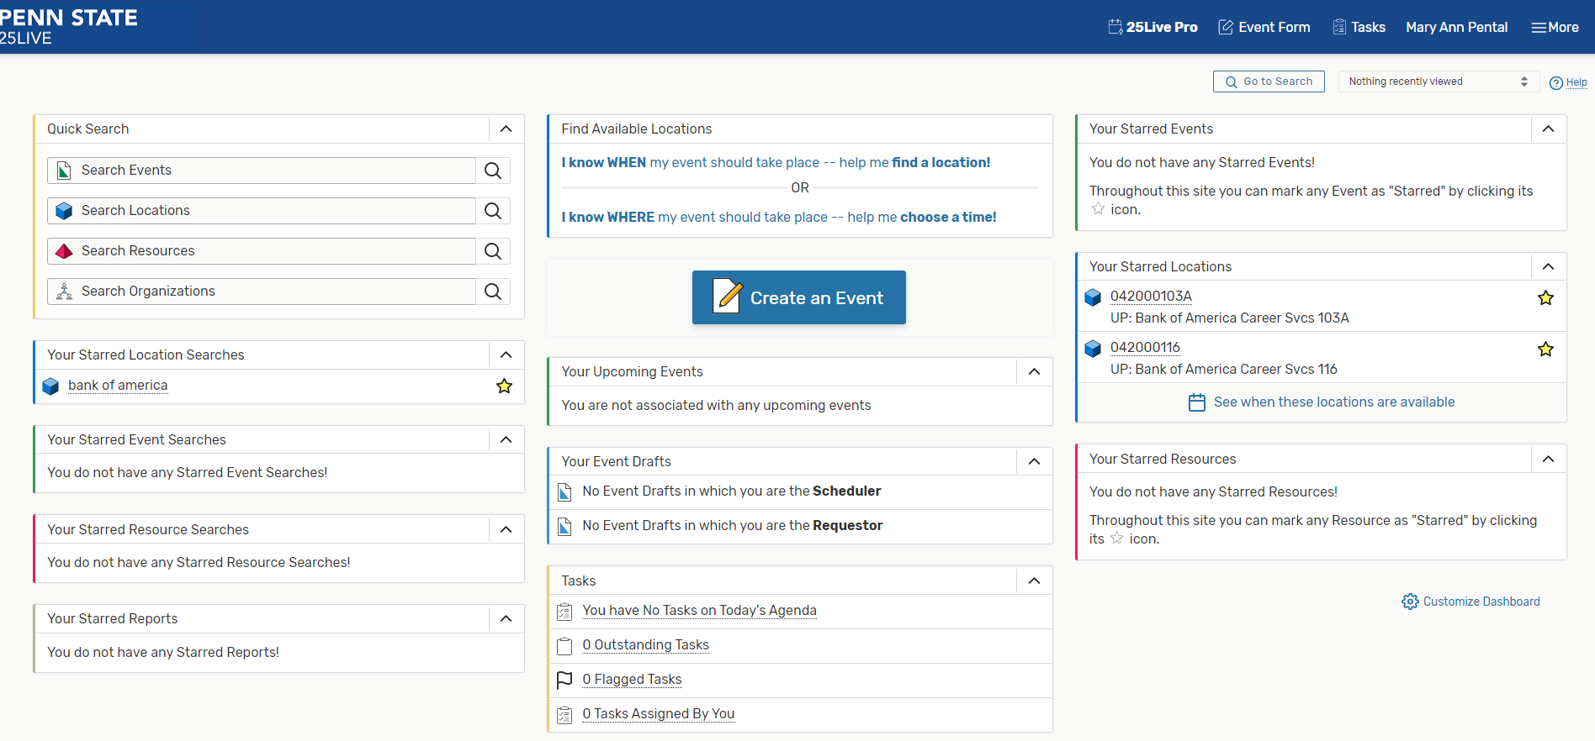

- Q. How do I find my events, locations, and resources quickly?
- To quickly search for events, locations and resources you can utilize the “Quick Search” element within the Dashboard. You must enter at least 2 characters into the search field and then click enter or click on the search glass to right of the search field.
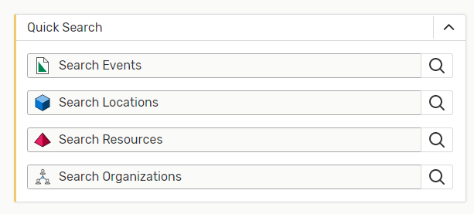

Your events are also displayed in the “Your Upcoming Events” element within the Dashboard.

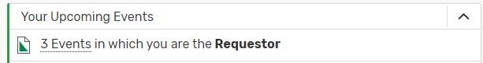

Lastly, starring locations, resources and organizations is a quick tool you can use so that your frequently used objects will populate on your dashboard as well as populate at the top of the list when searching for the object during an event request submission.

To star a location search for the object using the “Quick Search” or the search option available in the more menu button in the upper right-hand corner of the dashboard. Once you have identified the object you wish to star, click the white star located next to the object. The star will fill with yellow once you have successful starred the object. Your starred objects will appear on your dashboard once your session is refreshed.
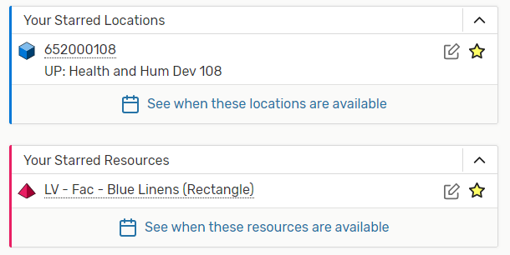

- Q. How can I find out if the space I’m interested in is available?
- To check room availability visit Penn State CollegeNET https://25live.collegenet.com/psu/pro. Using the quick search element on the dashboard, type your desired building into the location search field then type enter or click on the glass at the end of the field. This action will open the location search screen on the dashboard. You can then switch the view by clicking availability. You can then adjust the date by using the date selector.
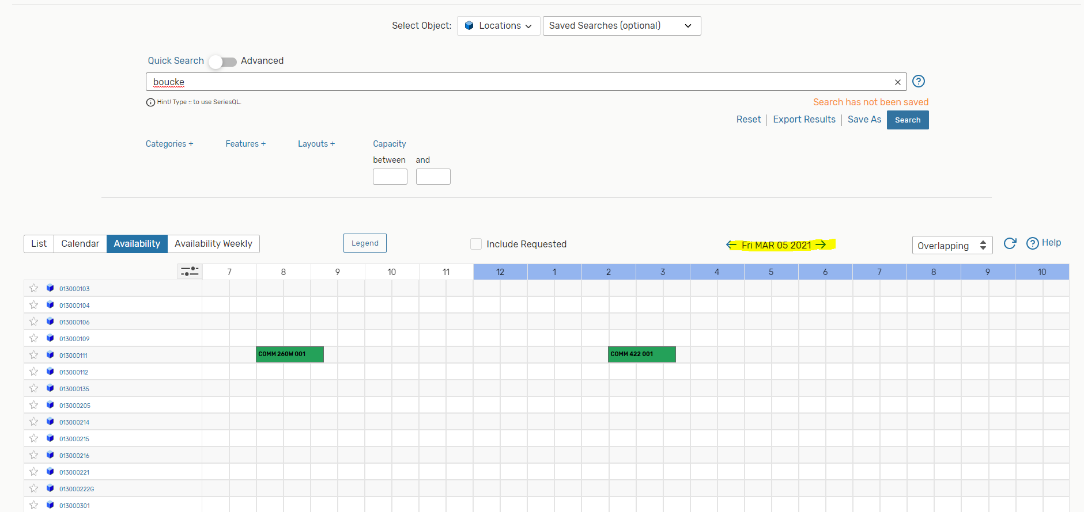

- Q. Why can’t I request an event location when 25Live shows it’s available?
A. This is typically encountered when users select an event time outside of the location's normal open/close hours.

- Q. Why can’t I find a location in 25Live?
A. If you are not able to find a specific location in 25Live, the location you are trying to request may be unavailable on the date/time that you are requesting. Additionally, not all locations are available for request by all users.

- Q. How do I request a University classroom?
- To request a University classroom you will utilize 25Live at the following link: Penn State CollegeNET https://25live.collegenet.com/pro/psu.

- Q. What is an event reference number? Where can I find it?
A. Each event in 25Live is assigned an event reference number that is specific to your event. The event reference number is located on your event confirmation as well as the subject line of the email you received with your attached event confirmation. Given the tremendous amount of events in the system it is much easier for us to identify your event by the event reference number. Please keep note of it, and refer to it in email or phone conversations with your event scheduler.
Example: 2021-AHJBBF. The below image with the event id shown on the event details.

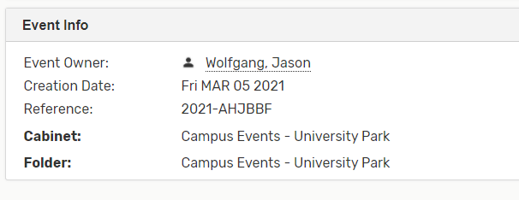

- Q. Why doesn't my event show up on the calendar immediately after I put the request in?
A. Most event requests need to be approved and will not populate on the calendar until approval has been granted. Please do not submit duplicate event requests for the same event.

- Q. Where can I find my event request?
- To quickly find your event requests view the “Your Upcoming Events” box on the Home tab dashboard. To view more detailed information, click on “Event in which you are the Requestor” and a more detailed listing with a quick link to the full event details will display.

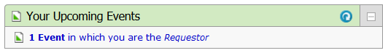

- Q. How long does it take to process a room request?
- Please submit requests as far in advance as possible and allow approvers at least 48 hours to approve or deny your event requests prior to following up, unless your event takes place within that timeframe. When a request has been submitted, an email confirmation is sent to the requestor, noting that the request is tentative. Once the event is approved or denied another email confirmation is sent to the requestor. Events are not confirmed in any other way. More complex event requests may take longer to process and may include additional steps.

- Q. How do I follow up on an event request?
- To identify the individual(s) who will be approving your event you will need to search and find your event in 25Live, open the event details and select the Task List. This will expand the information to display who is “Assigned To” the outstanding task needing approved or denied. When contacting one of the individuals please be sure to include the event reference id.

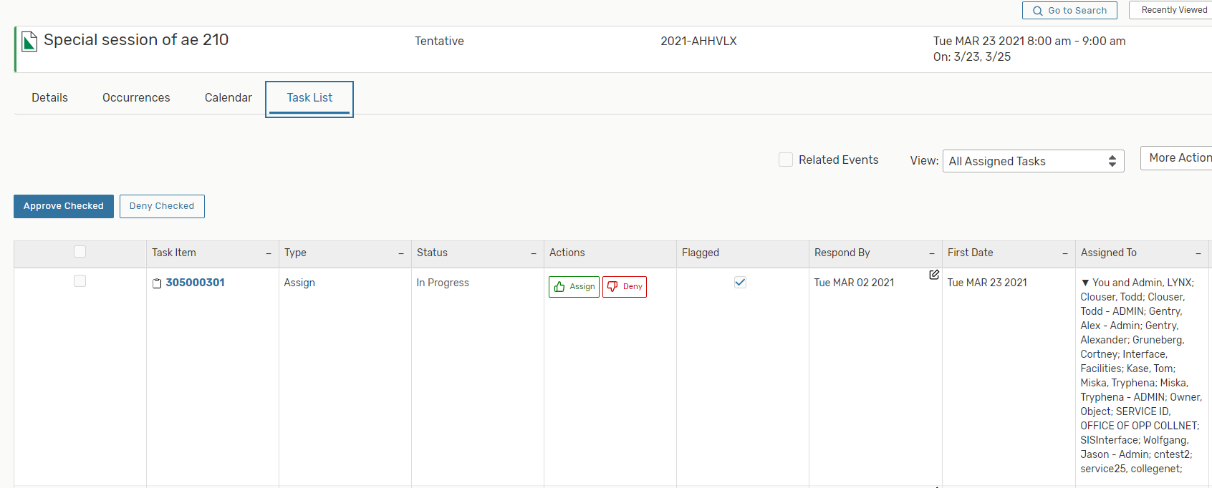

- Q. How can I make changes to my event?
- Once your event has been saved, you will need to contact the approver of the location and/or resource to modify the Event Name, Event Title, Sponsoring Organization, Expected Attendance, Promotional Information, Date and Time, and Comments. Please follow the steps in the Q/A “How do I follow up on an event request?” to identify who the approver(s) are.
If the event is in a tentative status you can change or remove the location/resources associated with the event. To remove a location/resources you will click red remove for the location or resource and then click save. See the below screen for an example. These changes require a new approval and will be routed to the appropriate individuals once the event is saved again.

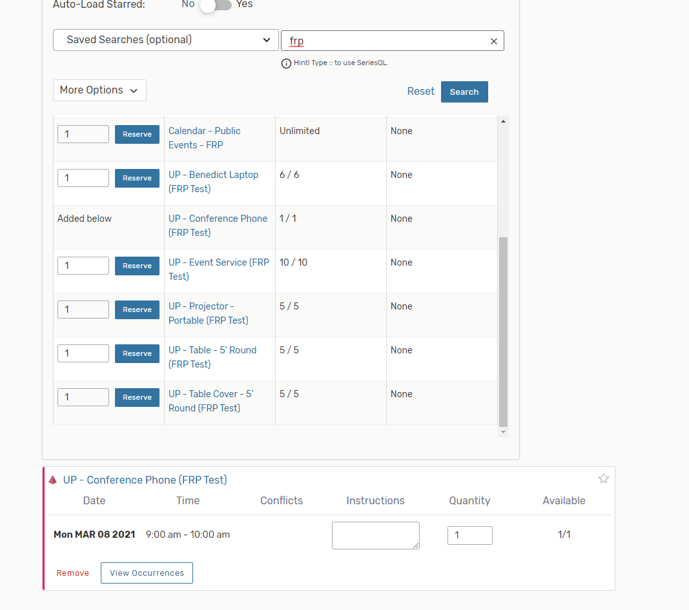

- Q. I submitted a request and it is in tentative status. Now, I need to make a change. Can I edit an event?
- As the requestor you are able to make minimal changes to your event when in a tentative status. You can do this by searching for and opening your event. Then click on “Edit this Event” which will open the event creation screens. You can then make the necessary changes and save your event. Some changes require a new approval and will be routed to the appropriate individuals once the event is saved again. To change event details that you do not have access to, contact the event approver. Please follow the steps in the Q/A “How do I follow up on an event request?” to identify who the approver(s) are.

- Q. I submitted a request and it is in confirmed status. Now, I need to make a change. Can I edit an event?
A. If your event has been confirmed you are not able to make additional edits. You will need to contact the individual(s) who approved it and sent your confirmation to edit aspects of the event. Please follow the steps in the Q/A “How do I follow up on an event request?” to identify who the approver(s) are.

- Q. How do I cancel/delete my event?
A. Events in 25Live cannot be deleted, however, to cancel your event you will need to contact, via email, the approver who you received your confirmation email from. If the event has yet to be confirmed, please follow the steps in the Q/A “How do I follow up on an event request?” to identify who the approver(s) are.

- Q. I am receiving an error stating an event is “locked.” What does this mean?
A. When receiving an error that an event is locked you will not be able to edit the event. This means another CollegeNet system user has the even open currently within their browser. To identify who has an event locked please email events@psu.edu. If it can be verified that the user is not currently working in the event, the Event Programming Team can unlock the event.

