CollegeNet-25Live Frequently Asked Questions - Schedulers

25Live is the online scheduling component of CollegeNET. This document answers frequently asked questions about the 25Live scheduling system.

- Q. How do I approve or deny a location or resource request?
A. Requests awaiting approval will appear in your “Tasks” on the Home tab in 25Live.
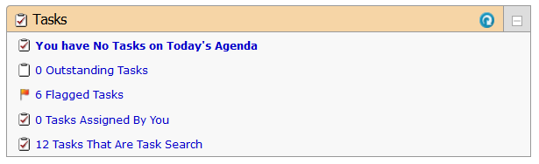

Click on your “Outstanding Tasks,” open the event from the task list, assign or deny the location/resource from within the event. Next change the event state to confirmed if approving the object requests. If denying the object requests leave the event status in a tentative status. Then send the confirmation using the more actions drop-down. Once this is completed the task will be removed from your tasks list.

- Q. How do I make sure to approve requests in the order they were submitted?
- 25Live will allow requestors to submit requests for the same location or resource until it is in approved status. As such, to be sure you are reviewing and approving/denying requests in the order they are received you should sort your task list by the “Reference” column.

- Q. What does a greyed out symbol mean?
A. When the symbol next to the location or resource is greyed out it indicates that the object is still in tentative status and has not been approved yet. Once it has been approved the symbol will fill with the appropriate color based on the object.

- Q. Why isn’t my report generating?
A. A cause for a report to not generate could be that pop up’s are not enabled/allowed within your browser. Reports generate and present in a new PDF window. The size of the report may also impact the amount of time the report takes to generate. Selecting the “Email this report to yourself” is the best option when generating larger reports.

- Q. How can I reverse a denied location or resource?
A. To reverse a denied location or resource a 25Live user with assign/unassign or assign/unassign/approve will need to edit the event and add the location or resource to the event again and save the event. Please note, this does not change what is viewed in the task list and the object will still show in denied or canceled status, however, if the object symbol is in color within the event it has been successfully re-added to the event.

- Q. How do I remove a location or resource from an event that has already been approved?
A. To remove a location or resource that has been assigned/approved already you will need to locate the event in CollegeNet, click on “Edit this Event”, move through the event wizard to the location or resource page and then click the red X on the location or resource selection that is located in the bottom right of the screen, click save. This will release the location or resource that was approved for the event and for locations will remove it from the locations calendar. If the request to remove the location or resource did not come from the requestor of the event, you will want to notify the request of this change by clicking on “More Actions,” “Email Event Details” and notify the requestor of this change to the event.

- Q. How do I cancel/delete an event?
A. Events in 25Live cannot be deleted, however, you can cancel an event. To cancel an event you will need to locate the event in CollegeNet, click on the “Event State” drop down and select Cancelled. When performing this action the system will automatically release any locations or resources that were associated with the event. You will receive a confirming email noting the event state is cancelled.
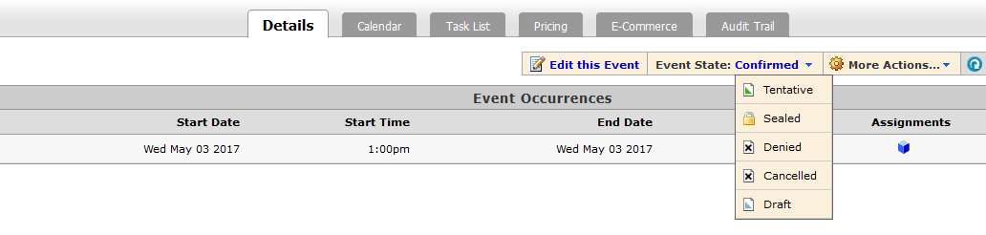

- Q. How do I find out who approved an event or course in a location I approve?
A. To identify who approved an event or course in a location you are an approver for you would search for the event in CollegeNet and once the event is displaying click on the “Audit Trail” tab. You then need to look for a “State Change” in the “Action” column and in the “Additional Information” column – “Changed event state from Tentative to Confirmed.” Then locate the “User” associated with the State Change. The Audit Trail displays their email address. If the email address is not known to you please search the Penn State Directory.
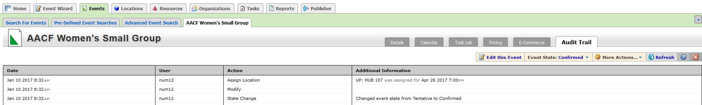

- Q. What should I do with an event that has an academic organization?
A. Events should not have academic organizations as the sponsoring organization. Example: EDPSY. Instead the department, office, institute, center or RSO should be used when submitting an event request that is not a course. As a scheduler, if you receive an event request with an academic organization as the sponsoring organization you should require the requestor to change the sponsoring organization or as the scheduler you can change the sponsoring organization if the correct organization is known to you.

- Q. What is a pending reservation?
A. Pending reservations are temporary holds that are put on locations while events are being created. You may see a pending reservation on a location availability calendar. These should go away when the request is submitted. If you have one that is not going away, email events@psu.edu.

- Q. I am receiving an error stating an event is “locked.” What does this mean?
A. When receiving an error that an event is locked you will not be able to edit the event. This means another CollegeNet system user has the even open currently within their browser. To identify who has an event locked please email events@psu.edu. If it can be verified that the user is not currently working in the event, the Event Programming Team can unlock the event.

