Event Search 25Live Pro

- Go to the hamburger menu: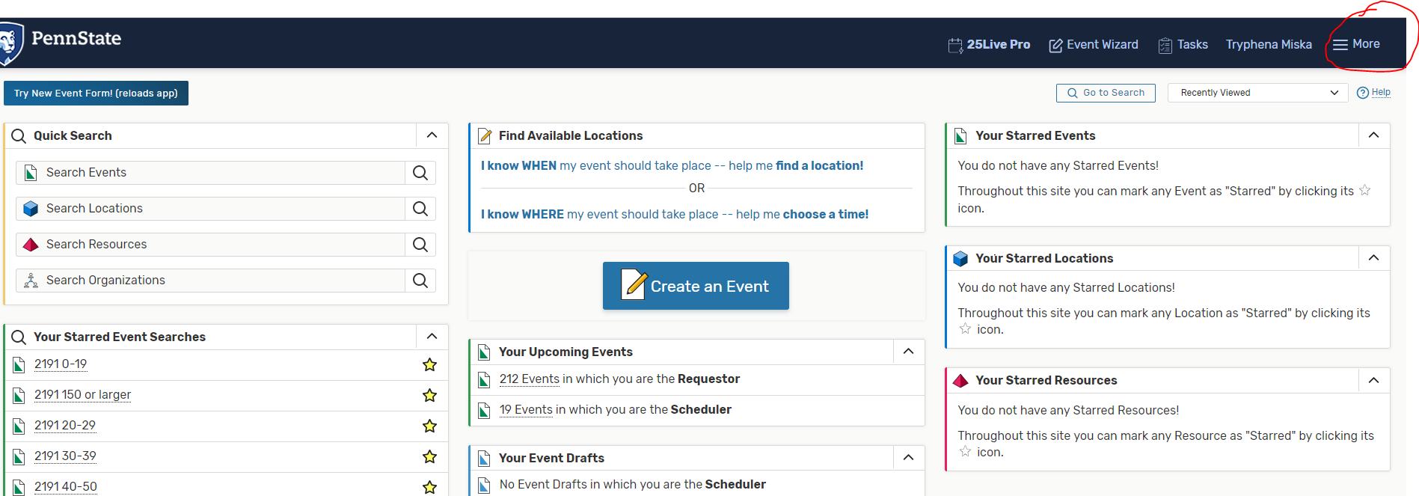

- Click Search:

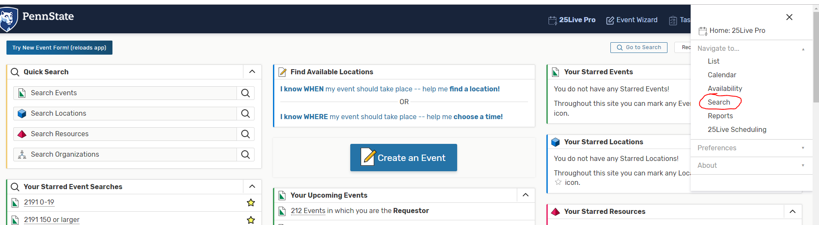

- Make sure you selected “Events” for Select Object: 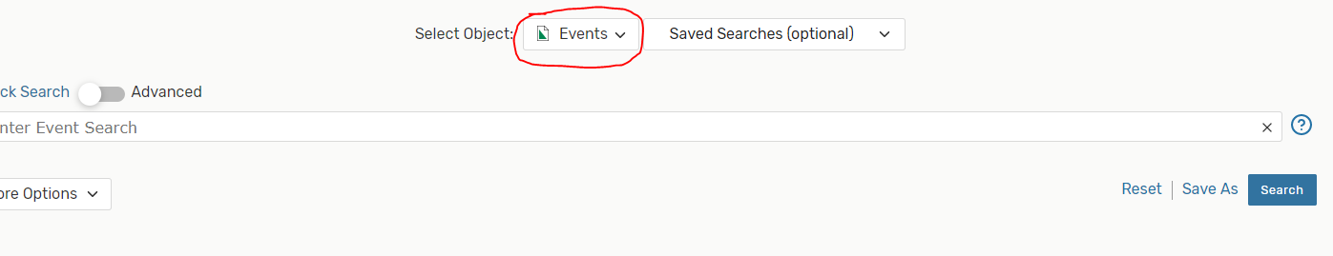
- Click More Options: 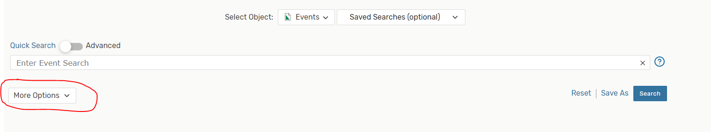
- Click on Categories: 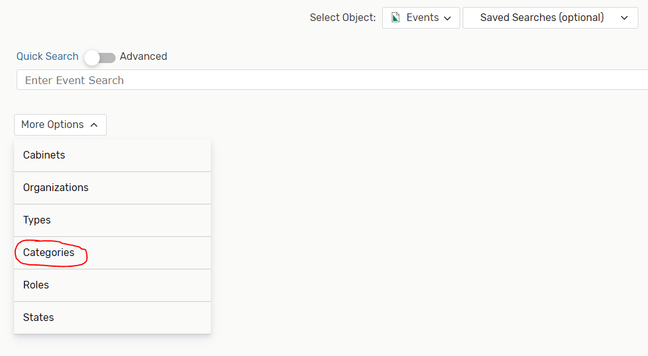
- Choose the term you want to look at and then click Done: 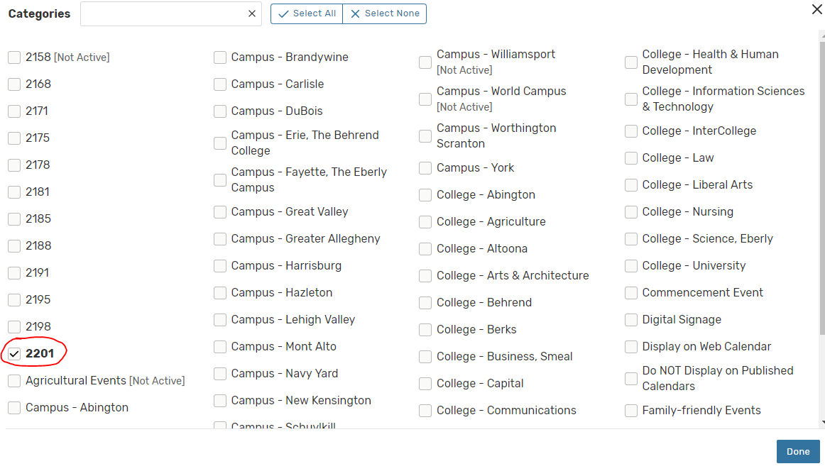
- Click on Organizations: 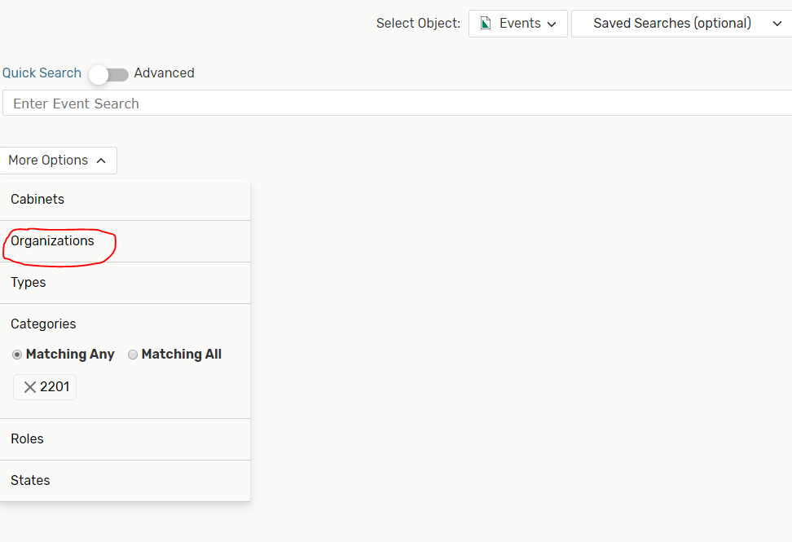
- Type in your subject (only select the subject code, don’t select the dept. code). Click Done: 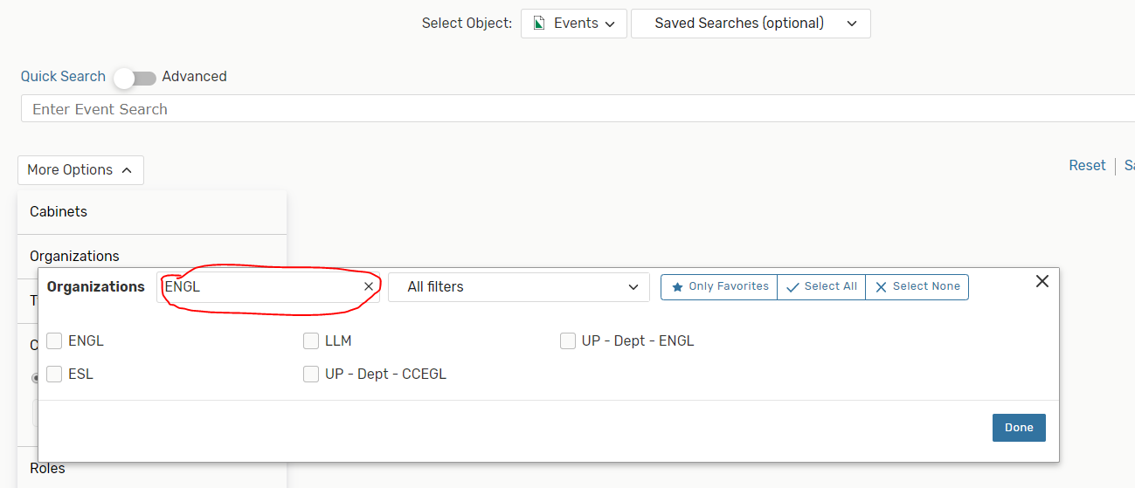
- Click Search-this will create a search of all of your classes for a given term. You can save the search by clicking Save As.

