Finding GPCs excluding Reclassified GPCs at University Park Location Search 25Live Pro

- Go to the hamburger menu: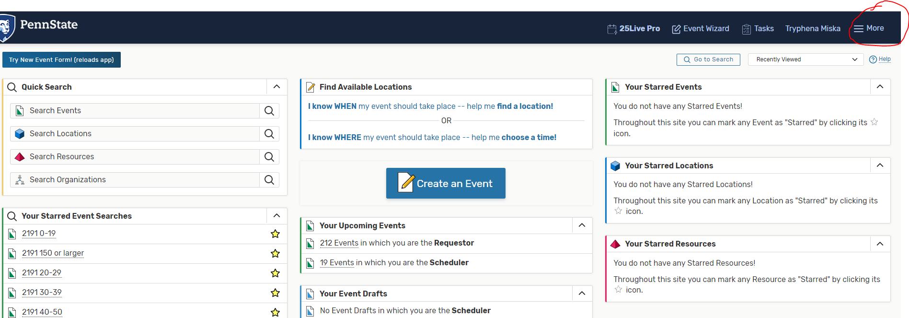

- Click Search:

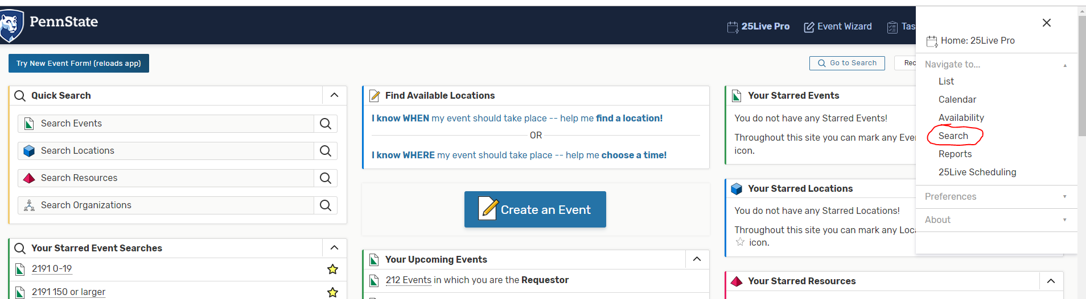

- Make sure you selected “Locations” for Select Object:
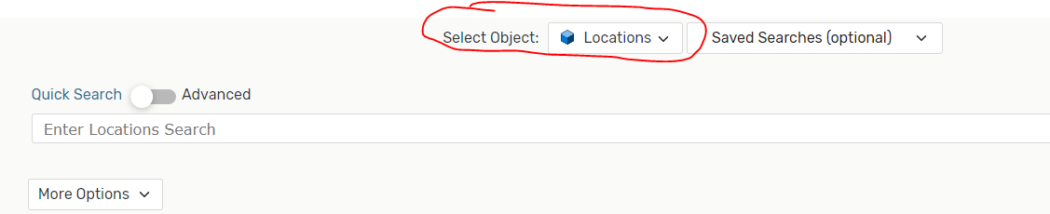

- Click More Options:
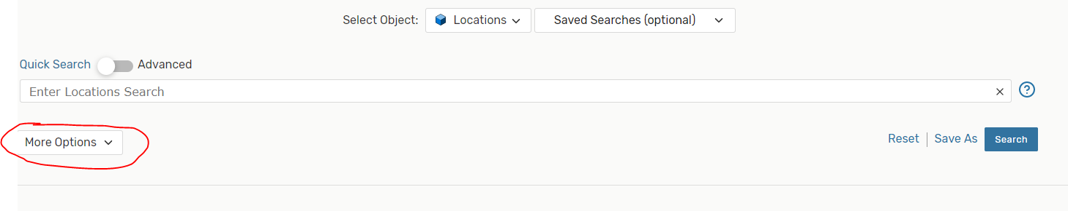
- Click Categories:
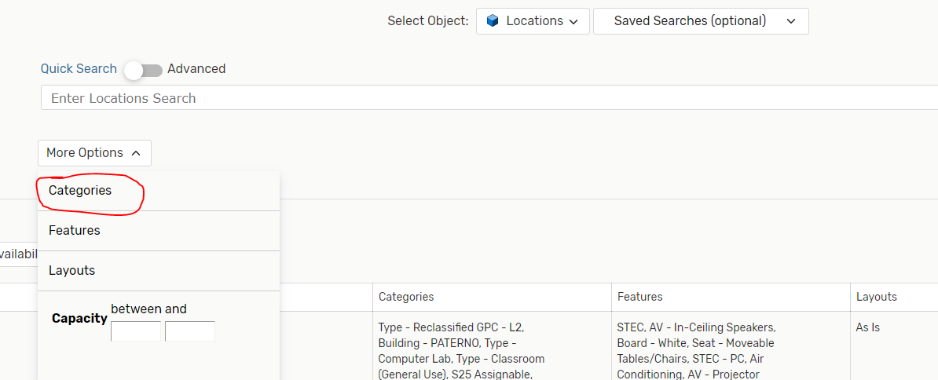

- Choose Campus-University Park and Type-Classroom (General Use) and then click Done: 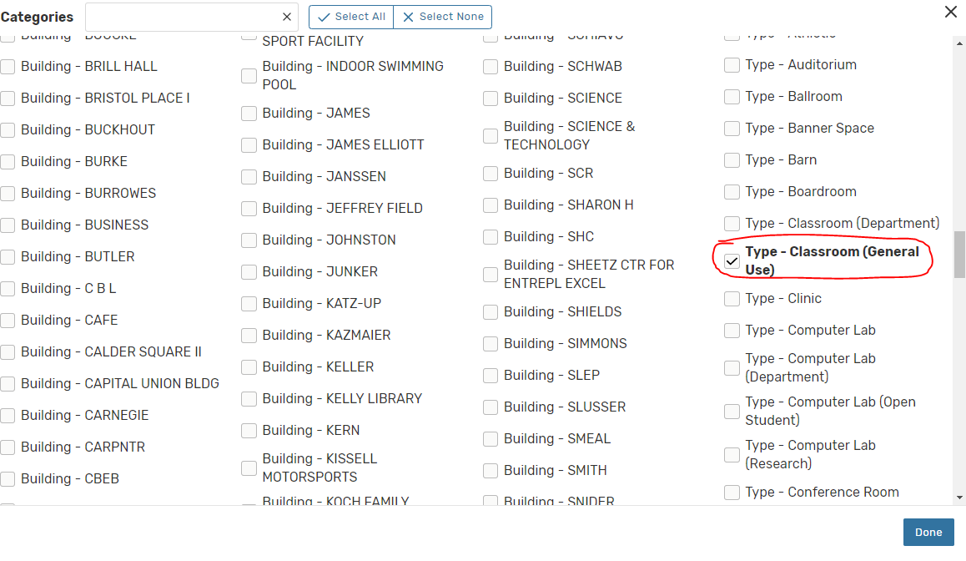

- Click Matching All:
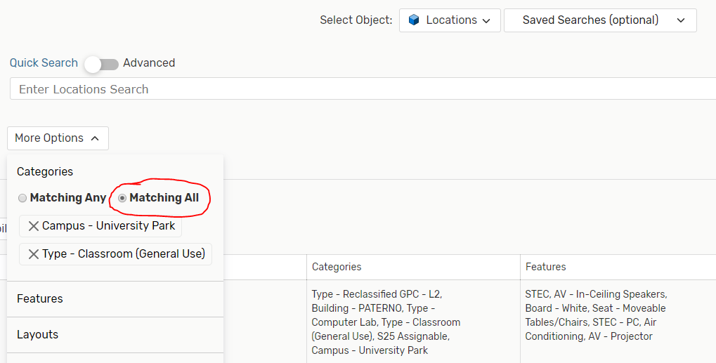

- Click Search. This will give you all the general purpose classrooms at University Park. 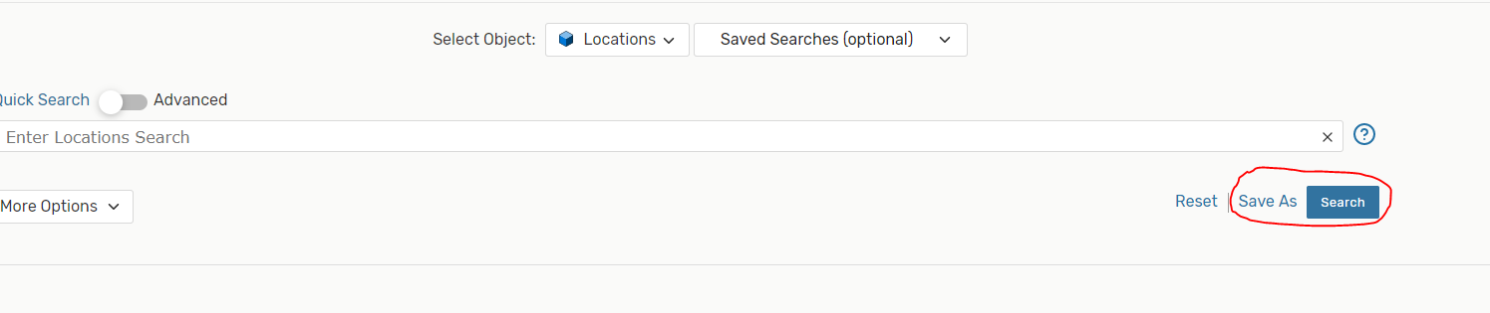

- Change Quick Search to Advanced: 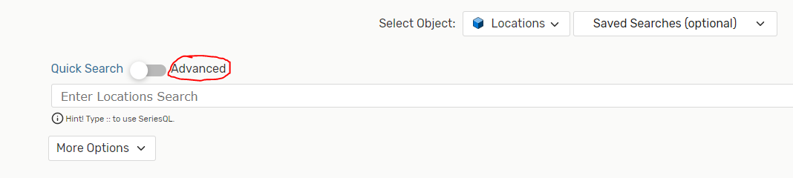

- Click Add Criteria: 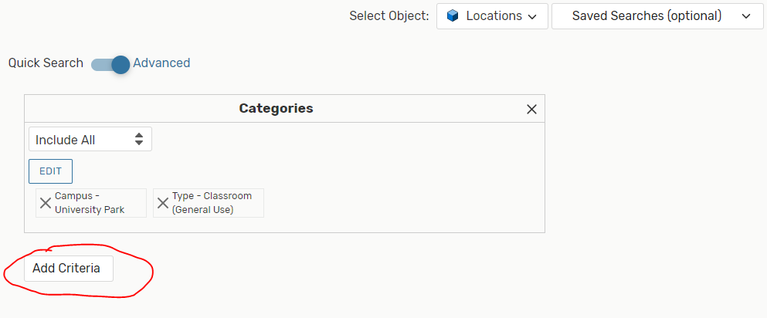

- Click Categories: 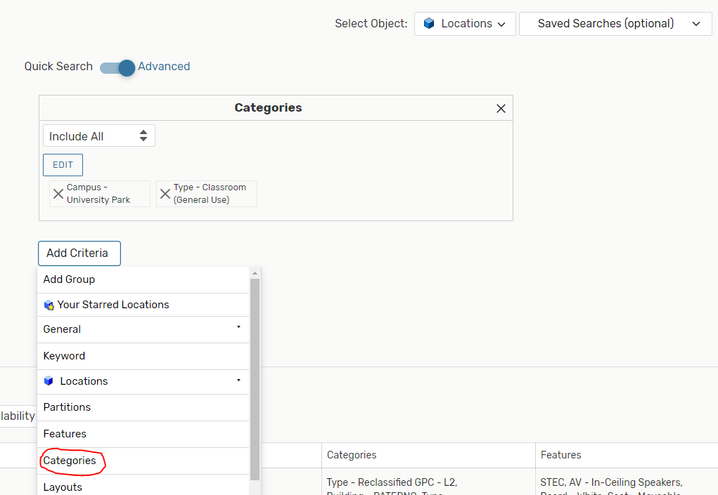

- Change Include Any to Do Not Include and click Edit: 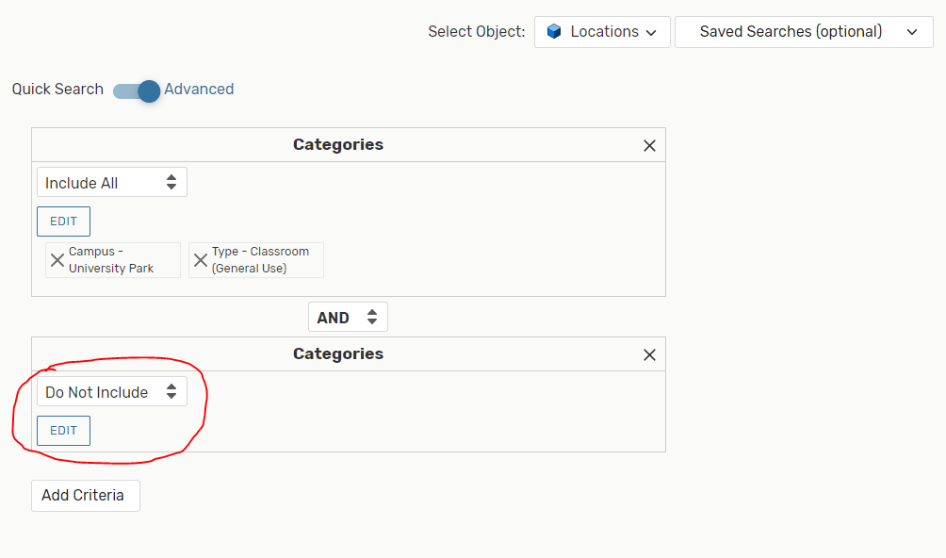

- Click on Type-Reclassified GPC-L1 and Type-Reclassified GPC-L2 and then click Done: 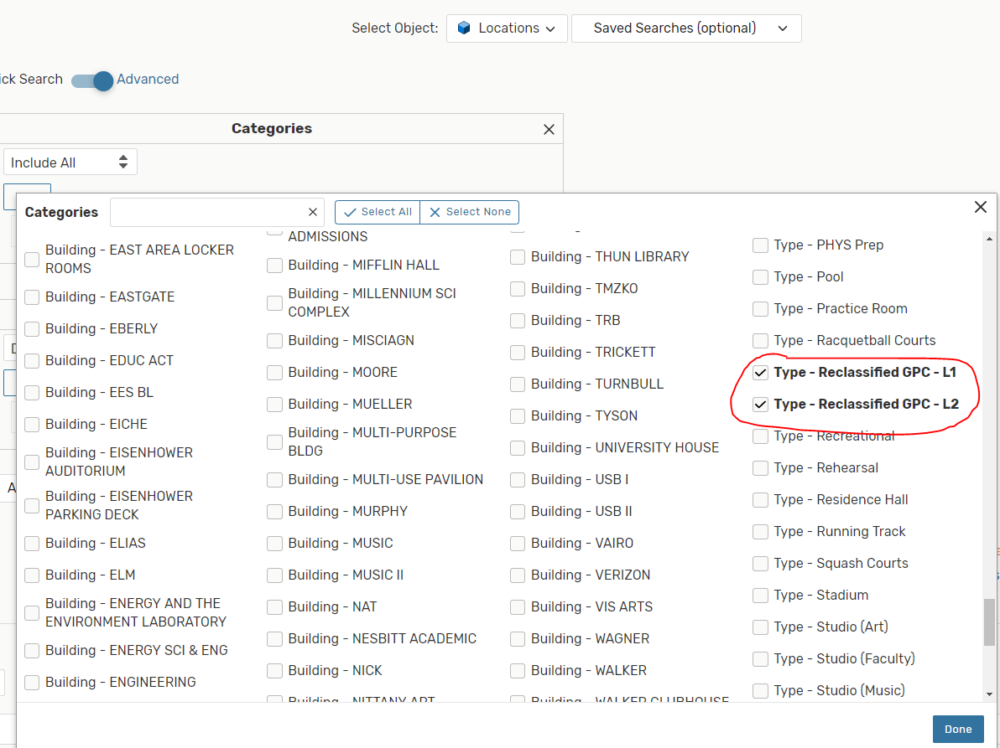

- Click Search. This will give you a list of GPCs excluding the reclassified rooms. You can save this search by clicking Save As: 