Finding GPC’s at University Park Location Search 25Live Pro

- Go to the hamburger menu: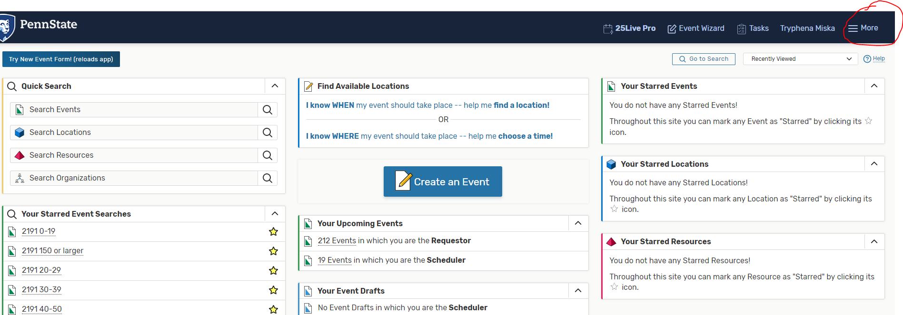

- Click Search:

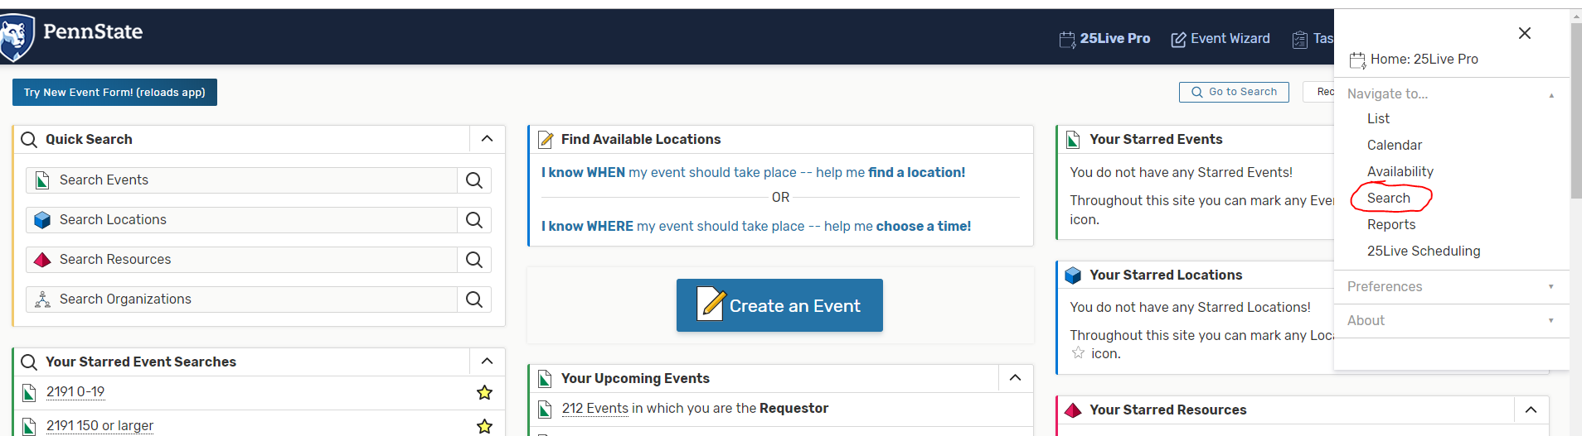

- Make sure you selected “Locations” for Select Object:
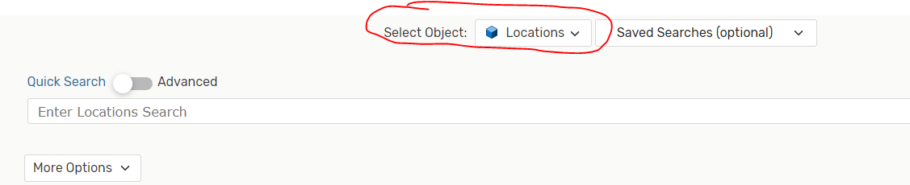

- Click More Options:
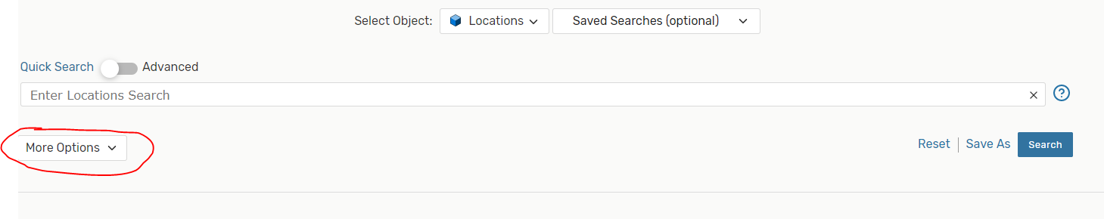
- Click Categories:
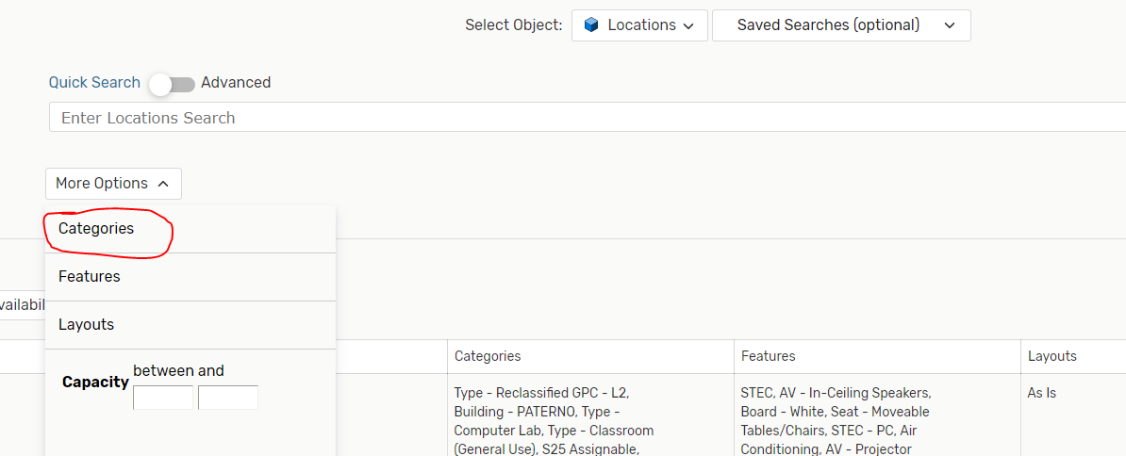

- Choose Campus-University Park and Type-Classroom (General Use) and then click Done: 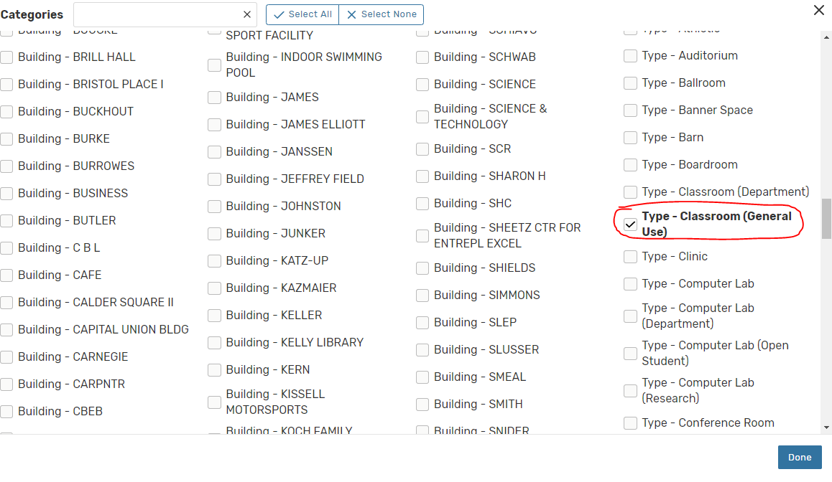

- Click Matching All:
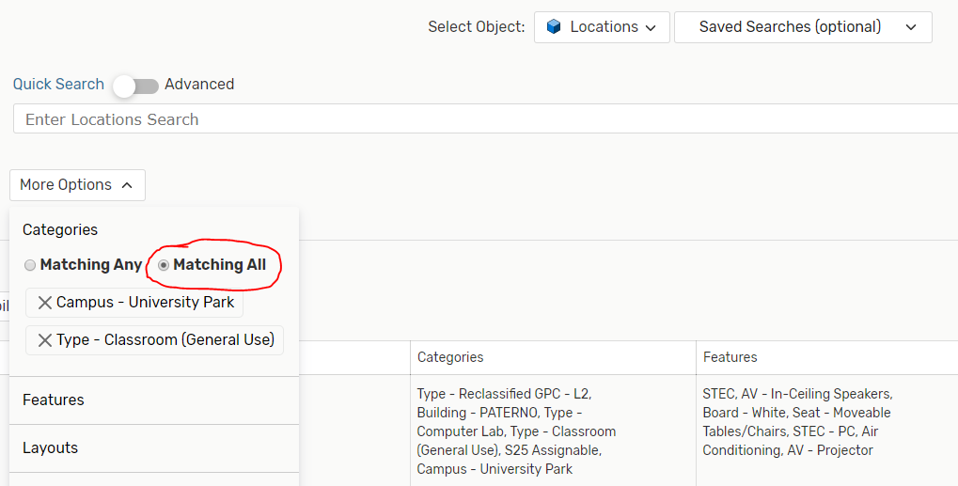

- Click Search. This will give you all the general purpose classrooms at University Park. You can save this search by clicking the Save As button: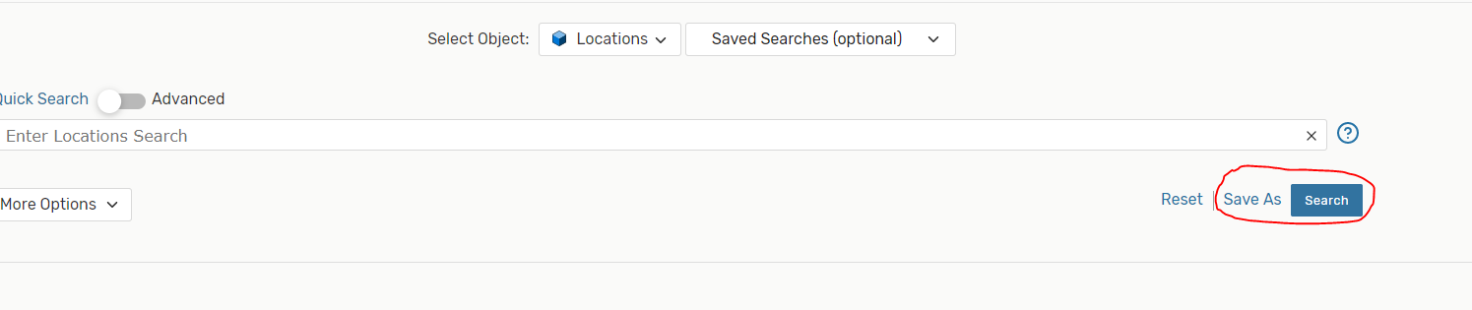

You can narrow down your location search by selecting different features to search by. For example, maybe you want to search for all ITECs at the University Park campus that are general purpose classrooms. To do this, follow the steps below:

- Leave your Categories search the way you have it from above, but then you will click Features: 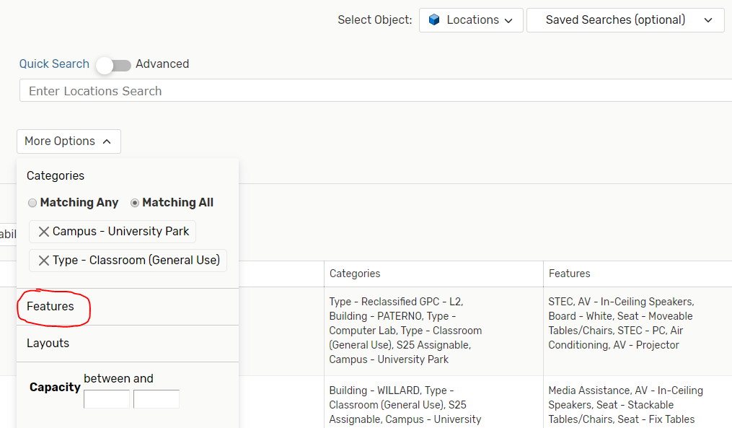
- Choose ITEC and click Done: 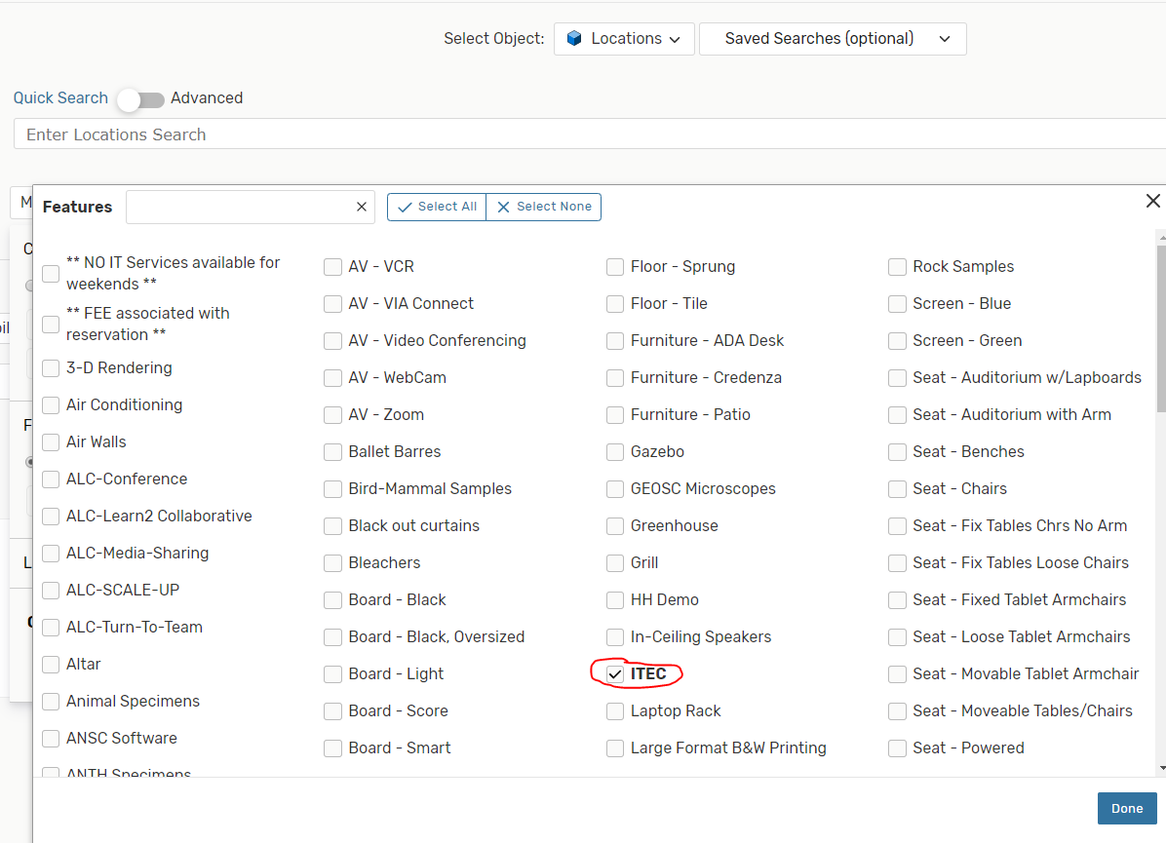

- Click Search. This will give you all the ITEC general purpose classrooms at University Park. You can save this search by clicking the Save As button:

You can set up similar searches for STEC rooms by changing the Feature to STEC.

