Class Meeting Patterns Dashboard in iTwo
- Navigate to itwo.psu.edu.

- Click the Dashboards button at the top right of the screen:

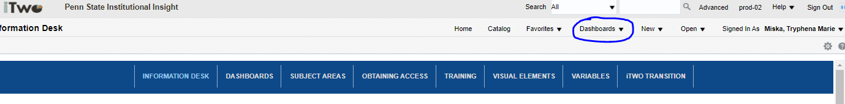

- Under Student-Enrollment and Instruction, click on the Class Meeting Patterns link: 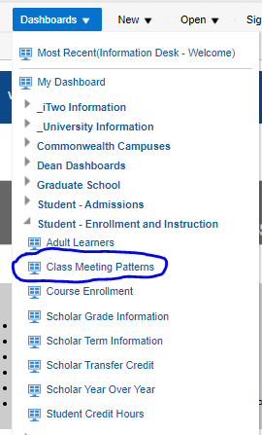

- Enter term, career, campus, and class academic group (college) that you wish to view and click the Apply button:

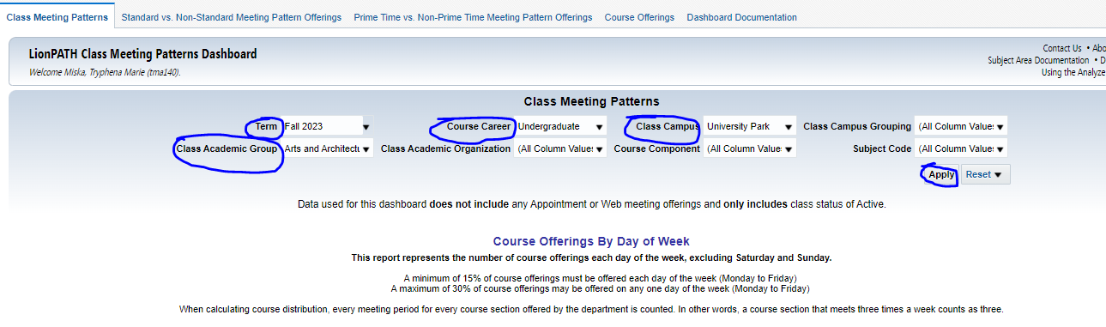
- The Course offering by Day of Week chart will show your distribution of classes throughout the week. The policy about this is listed on the dashboard:
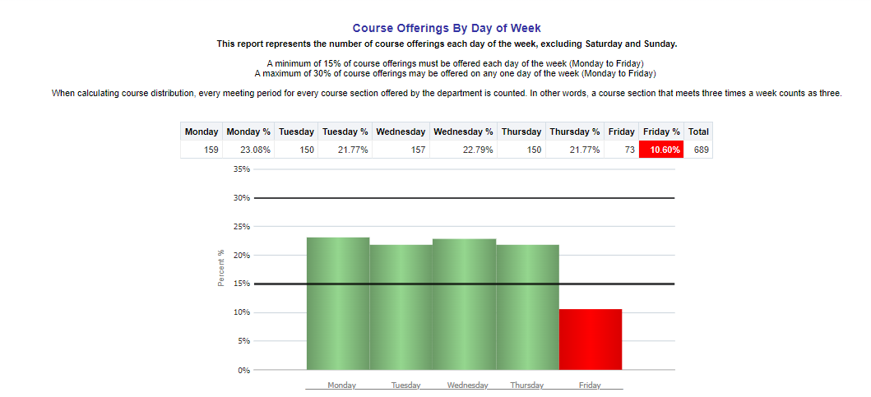

- Scrolling to the bottom left of the screen will show you the percent of standard and non-standard classes that are being offered:
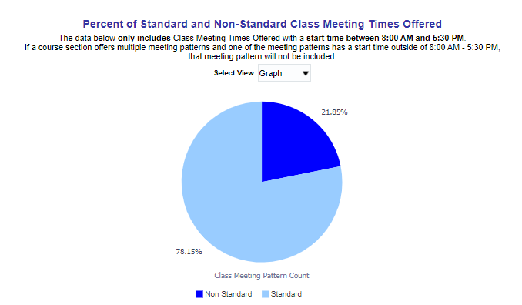
- Scrolling to the bottom right of the screen, you will find the percent of prime time vs. non-prime time classes. The policy about prime time classes is listed on the dashboard:
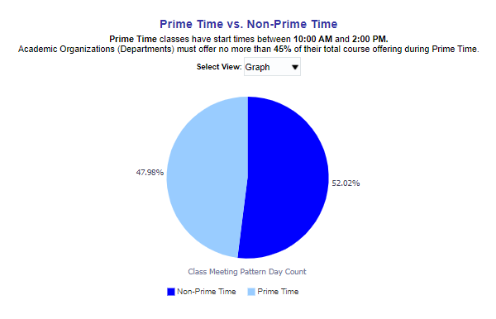
- If you are looking for additional information, there are tabs at the top of the dashboard that will show you your standard vs. non-standard meeting pattern offerings, prime time vs. non-prime time meeting pattern offerings, and all your course offerings. There is also a tab that goes into detail about the dashboard and how it can be used.
