From: OUR‐RegistrarEmail
Subject: Spring 2021 Conflict Exam Schedule Good Morning,
The Oﬃce of the University Registrar has scheduled a conflict final exam for one or more of the classes you are currently teaching for the Spring 2021 semester. We have scheduled student conflicts who have three exams in one day, or three exams consecutively in a twenty four hour period. You can find your exam schedule by going to https://www.registrar.psu.edu/exams_faculty/ once you log into this page, you can click the “View Your Final Exam Schedule” button to view your schedule.
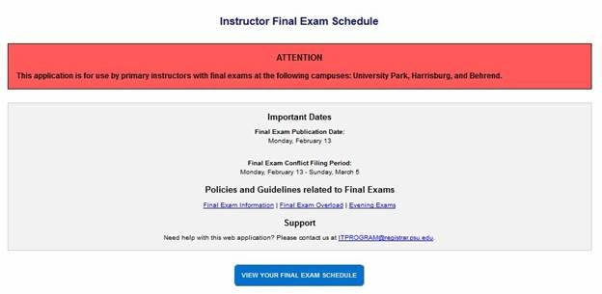

Your final exam schedule will appear showing all the sections that have an exam scheduled and any conflict exams that may have been scheduled. Conflict exams are designated with a “VIEW” button in the first column.

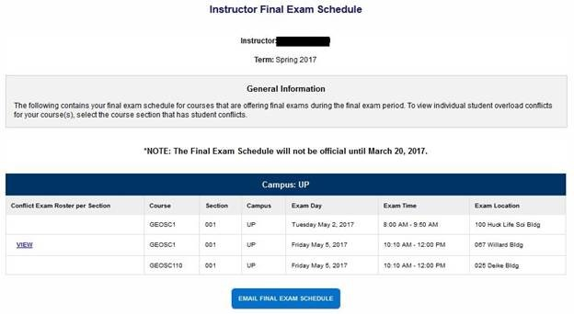

If you would like to email yourself a copy of your exam schedule, click the “Email Final Exam Schedule” button and a copy of your exam schedule will be sent to your Penn State email address.

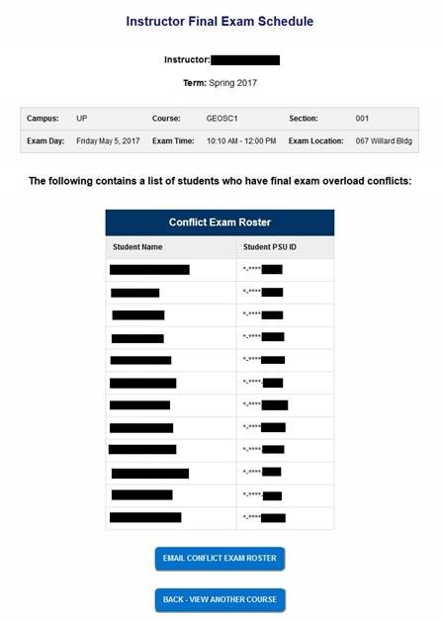

To view the students that have been scheduled to take the conflict exam that has been scheduled for you, click the “View” button. This will bring up the student’s names and last four digits of their PSU ID. You can email yourself a copy of the roster by clicking the “Email Conflict Exam Roster” button.
If you have any questions, please feel free to reach out to us at esmail@psu.edu. Sincerely,
Oﬃce of the University Registrar Pennsylvania State University

