COVID Instruction Modes
COVID Remote-synchronous- have actual meeting pattern:
Change Instruction Mode to CR
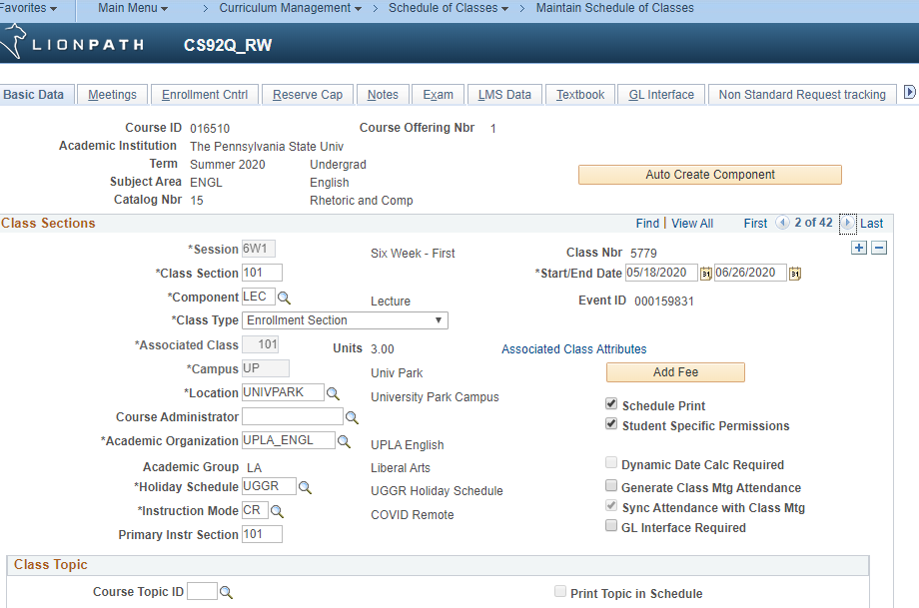
Change the Facility ID to ZOOM
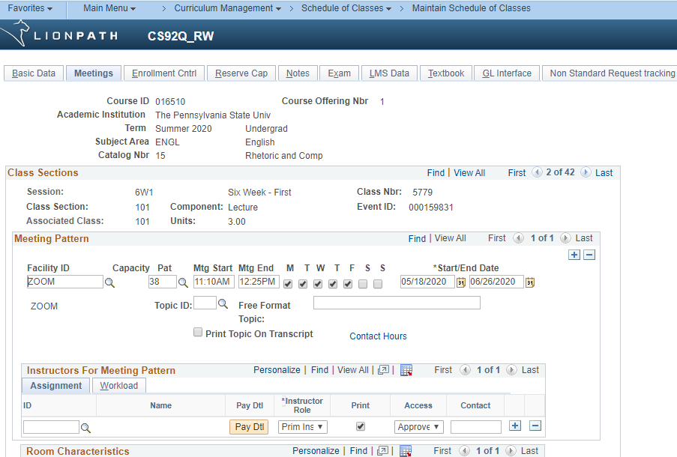
COVID Web-asynchronous- have web meeting pattern:
Change Instruction Mode to CW
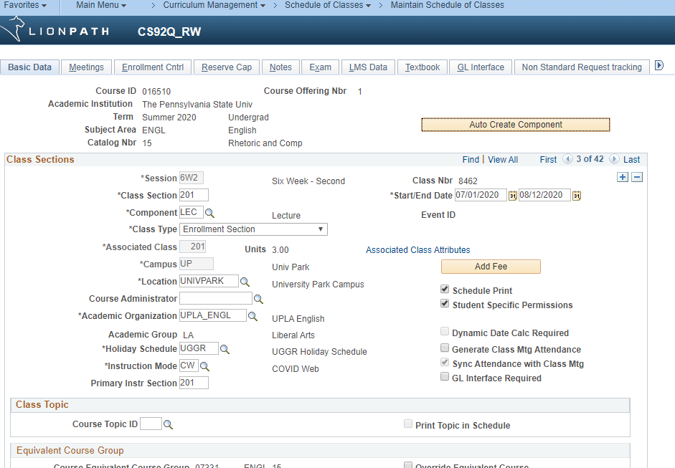
Change Facility ID to WEB and Pat to 36- remove times and days
